
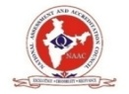
SITAM
SATYA INSTITUTE OF TECHNOLOGY AND MANAGEMENT
Gajularega, Vizianagaram, Andhra Pradesh, India-535002.
Accredited by "NAAC"
Approved by AICTE and Affiliated to JNTUK, KAKINADA
Email: sitam@sitam.co.in, Website:www.sitam.co.in
Telephone No:9676788811, 8978812341/2, Land Line: 08922-234775
IQAC- SATYA INSTITUTE OF TECHNOLOGY AND MANAGEMENT
Qualitative Metrics
Criterion 7-Institutional Values and Best Practices
7.1.9 | Sensitization of students and employees of the Institution to the constitutional obligations: values,rights, duties and responsibilities of citizens
Key Indicator 7.1 Institutional Values and Social Responsibilities

India, as a country includes individuals with different backgrounds viz., cultural, social, economic, linguistic, and ethnic diversities governed and guided by the Constitution irrespective of caste, religion, race gender. The staff and students of SITAM are educated on the constitutional requirements on the values, rights, duties and responsibilities of citizens enabling them to act in a manner befitting a responsible citizen. To equip students with the knowledge, skill, and values that are necessary for sustaining one’s balance between a livelihood and life by providing an effective, supportive, safe, accessible, and affordable learning environment. These elements are inculcated in the value system of the college community. The students are inspired by participating in various programs on culture, traditions, values, duties, and responsibilities by inviting prominent people. The institute conducts awareness programs on plastics, cleanliness, Swatcha Bharat, etc. involving students. The college establishes policies that reflect core values. The affiliating University curriculum is framed with mandatory courses such as Professional Ethics and Human Values, Constitution of India, Essence of Indian Traditional Knowledge, as a small step to inculcate constitutional obligations among the students. Major Initiative is to spread awareness regarding sanitation, living standards of life, and knowing one's personality. A separate NSS and NCC unit is started exclusively to encourage the students and the unit is successfully conducting activities to serve the society. Ethical Values, rights, duties, and responsibilities of citizens are some of the topics that are enlisted in Elocution, debate, and class presentations. Constitution day is conducted and preamble is administrated as an oath to all members in SITAM.

SITAM
SATYA INSTITUTE OF TECHNOLOGY AND MANAGEMENT
Gajularega, Vizianagaram, Andhra Pradesh, India-535002.
Accredited by "NAAC"
Approved by AICTE and Affiliated to JNTUK, KAKINADA
Email: sitam@sitam.co.in, Website:www.sitam.co.in
Telephone No:9676788811, 8978812341/2, Land Line: 08922-234775

IQAC- SATYA INSTITUTE OF TECHNOLOGY AND MANAGEMENT
Qualitative Metrics
Criterion 7-Institutional Values and Best Practices
7.1.9 | Sensitization of students and employees of the Institution to the constitutional obligations: values, rights, duties and responsibilities of citizens
Key Indicator 7.1 Institutional Values and Social Responsibilities

VISIT TO OLD AGE HOME

Date:01/10/2021
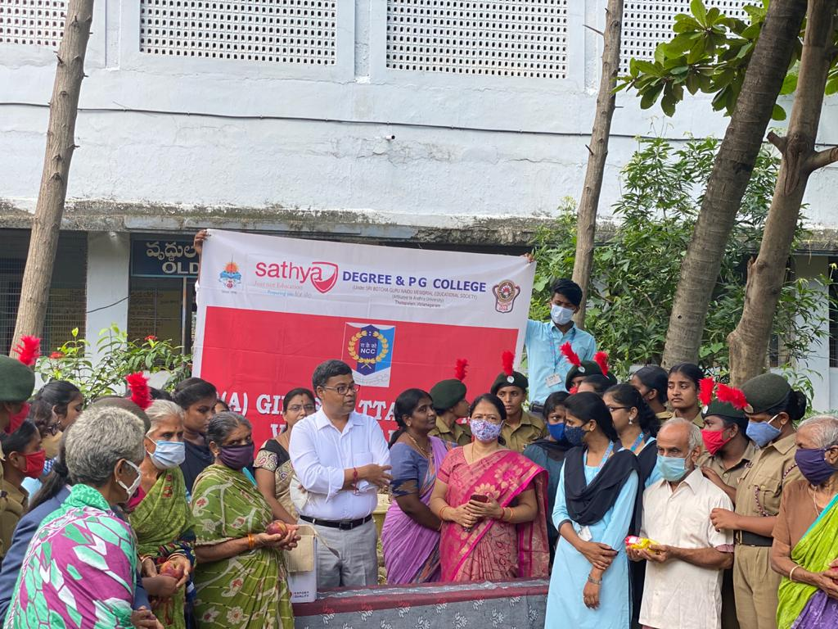Celebrations of “ International Older people Day”, by SITAM students: Today SITAM group NSS and NCC students celebrated the United Nations “ International Older People Day “, with inmates of Premasamajam , old age home in Vizianagaram. The students interacted with the inmates and felt emotional knowing their physical, psychological and emotional health issues. Every student promised to take care of their grandparents and make them happy. Director Dr.M. Sashibhushana Rao, Principal Dr .D.V.Ramamurthy, NCC ANO Lt. Satyaveni, Faculty Dr. Varudhini, Smt Naga Rani, Mr. Prudhivi& students participated in the interaction. The students and staff distributed fruits, biscuits and “Sugar Free” chocolates to each of the inmates.

SITAM
SATYA INSTITUTE OF TECHNOLOGY AND MANAGEMENT
Gajularega, Vizianagaram, Andhra Pradesh, India-535002.
Accredited by "NAAC"
Approved by AICTE and Affiliated to JNTUK, KAKINADA
Email: sitam@sitam.co.in, Website:www.sitam.co.in
Telephone No:9676788811, 8978812341/2, Land Line: 08922-234775
IQAC- SATYA INSTITUTE OF TECHNOLOGY AND MANAGEMENT
Qualitative Metrics
Criterion 7-Institutional Values and Best Practices
7.1.9 | Sensitization of students and employees of the Institution to the constitutional obligations: values,rights, duties and responsibilities of citizens
Key Indicator 7.1 Institutional Values and Social Responsibilities

Free Distribution of Clothes and Groceries to the poor

Date: 04/09/2021

To sensitize the students to the constitutional obligations and values and to make them as a responsible citizens ,SITAM indulges students to participate in free distribution of Clothes and Groceries to the poor. In memory of late Smt. Eswaramma , mother of honorable minister Sri Botcha Satyanarayana , revered Secretary and Correspondent Dr. Botcha Jhansi Lakshmi ,Dr. Botcha Sandeep and family members distributed clothes and groceries to the poor and needy. This program is held with the assistance of NCC & NSS students of SITAM Engineering College. Director Dr. Majji Shashibhushan Rao along with Teaching and Non Teaching staff participated in this program
.

