SITAM
SATYA INSTITUTE OF TECHNOLOGY AND MANAGEMENT
Gajularega, Vizianagaram, Andhra Pradesh, India-535002.
Accredited by "NAAC"
Approved by AICTE and Affiliated to JNTUK, KAKINADA
Email: sitam@sitam.co.in, Website:www.sitam.co.in
Telephone No:9676788811, 8978812341/2, Land Line: 08922-234775

IQAC- SATYA INSTITUTE OF TECHNOLOGY AND MANAGEMENT
Qualitative Metrics
Criterion 7-Institutional Values and Best Practices
Key Indicator 7.1 Institutional Values and Social Responsibilities

7.1.3 | Waste Management steps including:  - Solid waste management  - Liquid waste management  - E-Waste management

SITAM sees itself as an essential component of the ecosystem it lives in. As a result,

SITAM avoids any negative behaviors that can jeopardize the well-being of systems that are close to it. SITAM is an ideal ecological system, thanks to carefully designed building construction, plant life, and human support systems. To lessen its impact on animal, plant life, and human life, SITAM carefully evaluates the ingress/egress movement of solid, liquid, electronic, and other materials.

SITAM sees itself as an integral part of the natural system that supports it. Accordingly, SITAM prohibits any harmful activity that can thwart the flourishing of structures surrounding it. SITAM is an ideal natural framework which carefully considers building architecture, vegetation, and social networks that provide emotional support. SITAM minimizes the influence of the strong, fluid, electronic, and other waste material flora and fauna.

- Solid waste comes from various sources and is managed suitably:

- The fertilizer pit receives the strong waste from writing materials as well as the organic waste from nurseries and yards. The manure-pit-vermi-compost is used in the nurseries and in the kitchen garden.
- The solid waste from the dairy animals on the property is used as fertilizer for flowerbeds or even a kitchen garden.
- Some of the food waste is transported away from the manure-pit, and the remainder is securely dumped into the ditch that serves as the landfill. Sometimes, when the landfill ditch is filled in and a newer one is created. There is enough food remnant to generate biogas to cook 20% of the meals.
- Plastic waste is segregated and transported outside the Municipal Corporation for the proper handling.

- Waste water from restrooms and latrines is sent to the septic tank where the substance are safely decomposed.

- Waste water from the RO plant is transported to a safe location where it will saturate the earth and building to become future ground water. Water collection pits are planned to collect the RO residue water.

- Kitchen waste water is transferred to the manure pit.

- 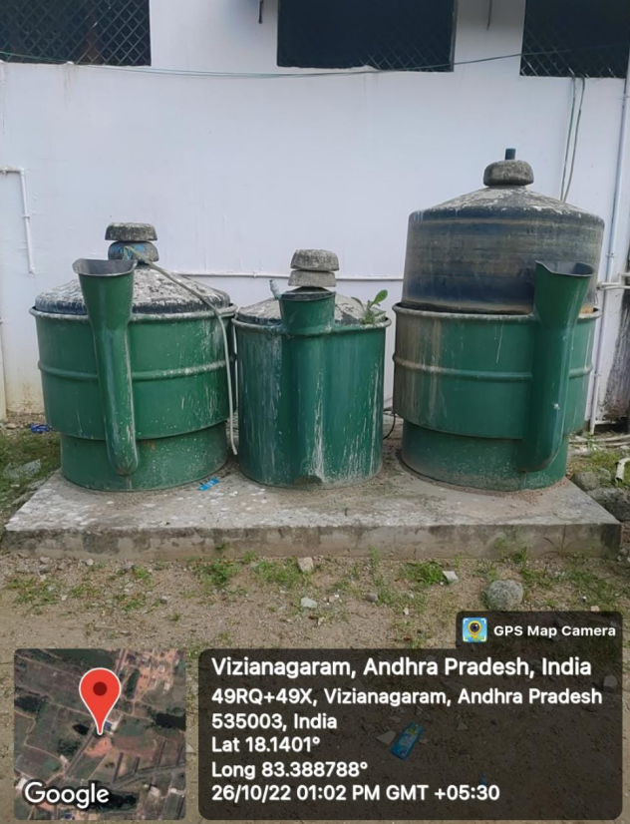

- Regarding Electronic waste materials:

- Faulty spare parts / assemblies are used for displaying illustrations.

- Scrap electronic material is sent to a third party for disposal in prescribed way.

- Condemned batteries are also delivered to a third party who manages them in prescribed way.

SITAM NSS Team members actively collect the E-waste and encourages the surrounding communities to segregate E-waste.

