SITAM’s tenets are always clear and streamlined about the safety and security of all employees through awareness and counseling. All issues are resolved amicably and yet with a firmness of justice.
Safety and Security
To maintain safety and security on campus the use of identity cards is mandatory for students as well as faculty. A visitor can enter the campus only by taking a gate pass. An adequate number of security guards are placed at different places on the campus. Security guards keep a watch on the entire area with the view to maintaining discipline on the campus and monitoring the parking area and other common areas of the campus. CCTV cameras are mounted on all public areas within the campus and within the building and are continuously monitored. Mentors and their teams monitor security at the hostel. Anti-ragging notices are prominently displayed. Any report in this regard is taken up by the Anti-Ragging committee of the institute. A Grievance cell addresses all problems faced by students. A fire extinguisher is provided in every wing of all buildings. Emergency needs like ambulance and doctor are made available as and when required immediately.
The laboratories are well equipped for all safety provisions depending upon their type. Girl students, lady faculty, and lady staff are treated with great respect in our institute. They are given equal opportunities in all events conducted in the institute. A women's grievance redressal committee exists in the institute which addresses the problems if any faced by girl students, lady faculty, and lady staff. All the preventive measures for safety and security are being taken care of.
Counseling
Every faculty in the department works as a mentor to a group of students allocated to them and they conduct regular meetings to check the progress in academics and also address any other problems to soothe the psychological need of students. The counselor provides expert counseling to the students for various behavioral issues as well as academic issues. Students are guided to face the stress and phobia of modern life. Counseling is also carried out for students taking admission into the institute. Details are provided to students about the admission procedure, and advice about various programs and selecting the best institute is given to them. A student is guided on the type of industry he should join, civil services, defense services, and also higher education options both in India and abroad by organizing various programs.

World Suicide prevention day

7/September/2021a program conducted at SITAM College on The world Suicide Prevention day -2021 at Seminar hall (AC). On the occasion of world Suicide Prevention Day -2021, District Legal Services Authority secretary and senior civil judge Lakshmi Rajya called on the youth not to commit suicide. Speaking as the chief guest at a state-level conference hosted by Spandana Ida International Foundation at SITAM College on Suicide Prevention Day on Tuesday morning, he said that life is very precious and life should not be taken lightly. Various scenes of youth committing suicide, problems, their solutions, punishment for suicide, and several sections are explained to the students as examples. The event was presided over by Alliance Club South India Chairman Samudrala Guru Prasad. College Director Dr.M.SashiBhushana Rao, Disha Police Station Sub-Inspector Lakshmi, eminent psychologist G.Himabindu, former director of VasaviVanitha Club Girija Prasanna and college principals conveyed a valuable message that students should not commit suicide. The speaker at the event was Sampada Ida International Foundation Speaker Krishna Rao, MP State Treasurer.

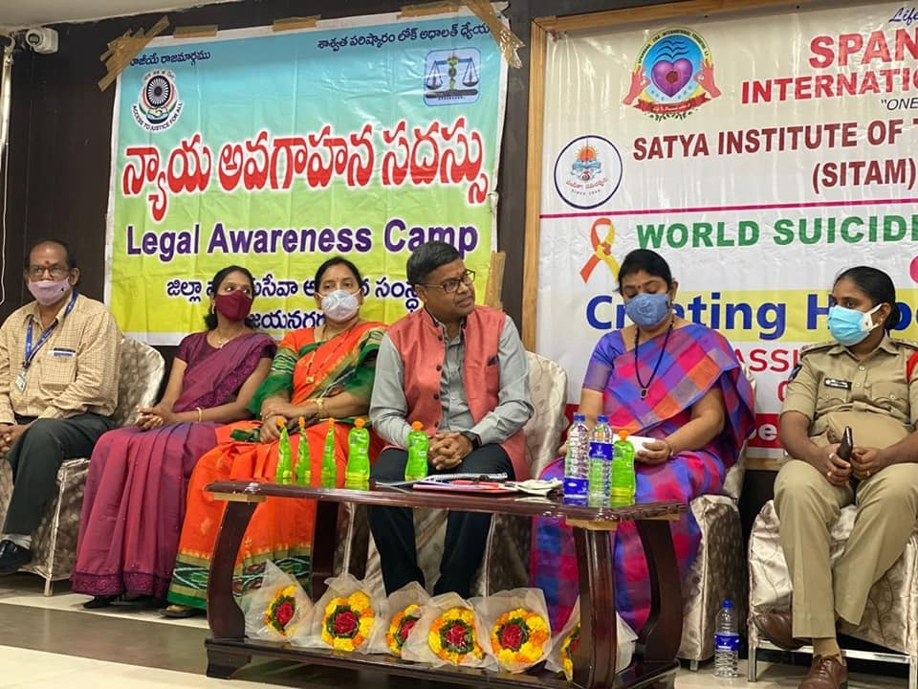 | 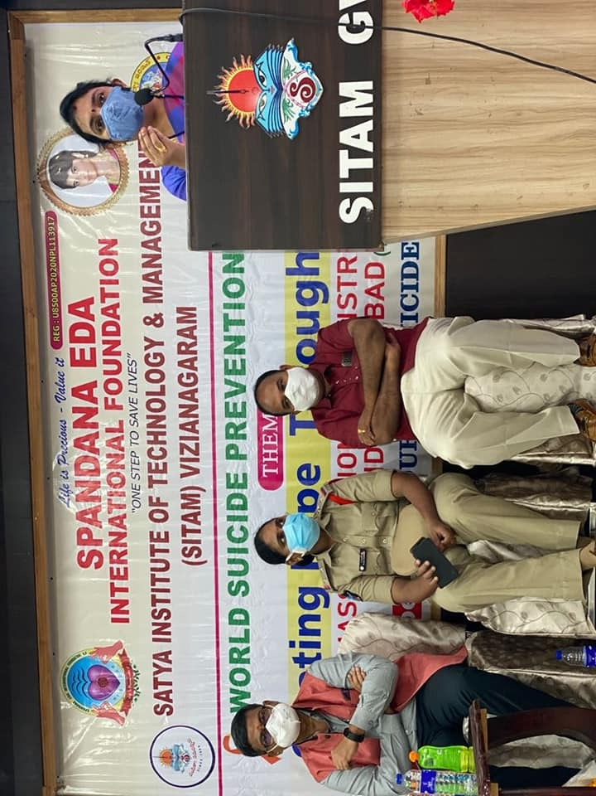
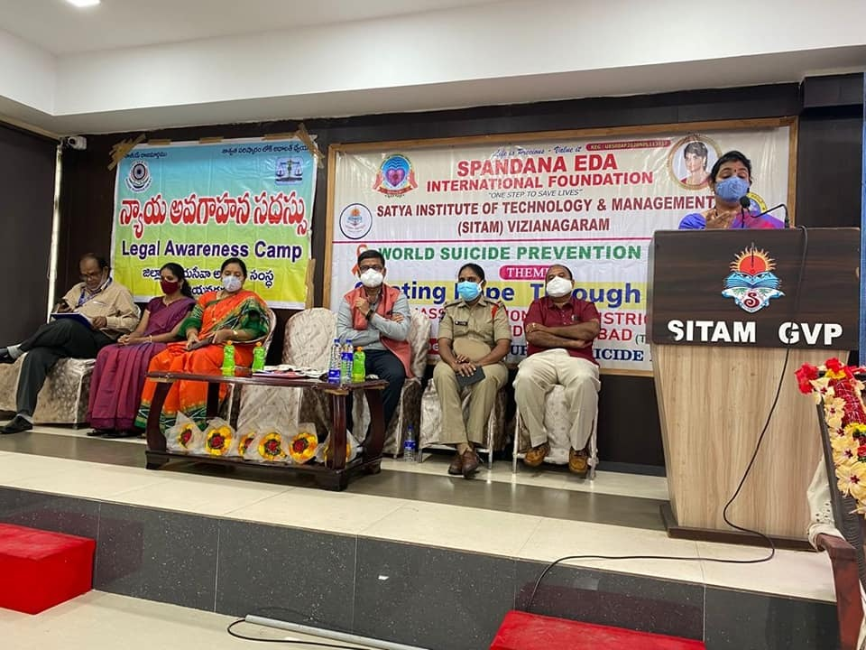 | 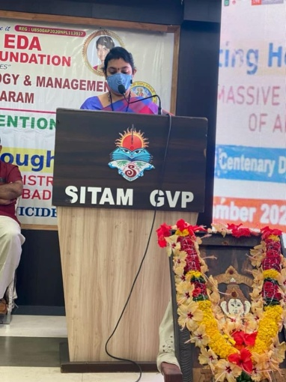
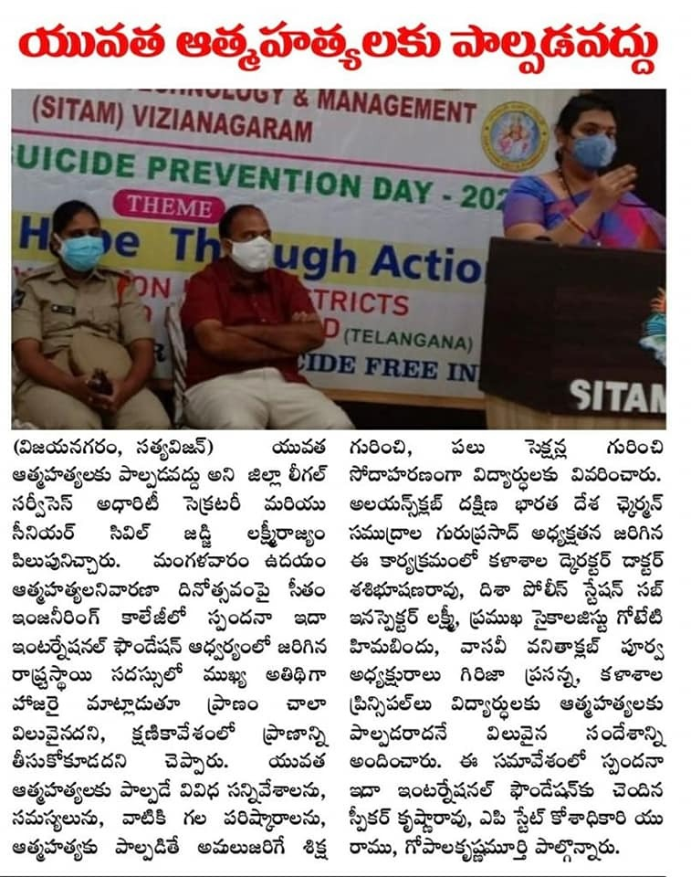 | 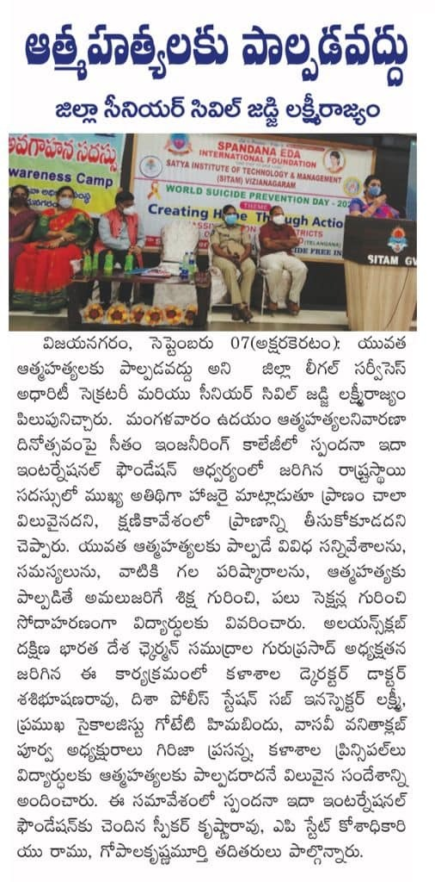

International Women's Day was celebrated grandly in SITAM

March 08/03/2022
Venue: SITAM College

SITAM Engineering College celebrated International Women's Day at SITAM Engineering College. On this occasion, various sports contests for female teachers, character contests for students, group discussion contests and winners were awarded. Arts and Crafts created by students were exhibited. Satya Institutions Secretary and Correspondent Dr. Botcha Jhansi Lakshmi as Chief Guest, Deputy Civil Surgeon Dr. T. Gauri Rama Lakshmi, Government Degree College Principal Dr. Swapna, MR Music College's late teacher Dr.Mandapaka Nagalakshmi, Annadata Sukhibhava founder Smt. D. V. Kanchana, social service activist Smt. V.Santoshi were invited and felicitated. Dr. T. Gauri Rama Lakshmi said that the women are advancing in all fields and still being discriminated against, women should not neglect her responsibility as a mother at any level. Dr.Swapna said that women should have self-confidence; women are powerful wherever they are. Women should encourage their children in fields of interest, and students should focus on learning the arts for peace of mind. Smt. Kanchana suggested to the students that they should not forget their mother. College Secretary and Correspondent Dr. Botcha Jhansi Lakshmi said that everyone should fight against gender discrimination in the society and women are equal to men. Women should strive for economic self-sufficiency, said. Dr.Majji Sasibhushana Rao, Director of Satya group of colleges, SITAM College Principal Dr. D. V. Ramamurthy, Satya degree and PG College Principal Dr.V. Sai Devamani, Vice Principal Smt. Ch.Venkata Lakshmi, teachers and students have participated.

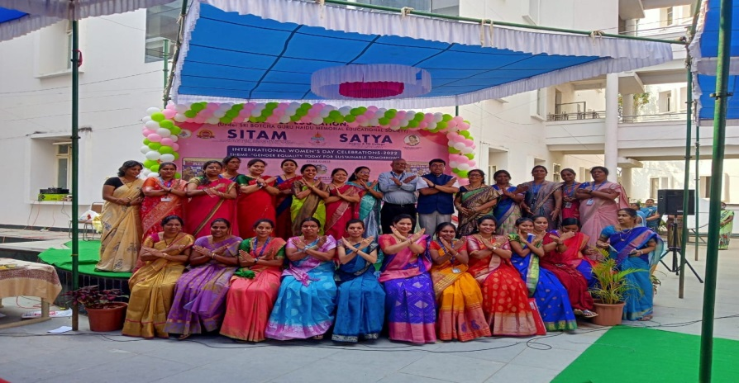

Awareness Conference on Women Empowerment

27/03/2022
An awareness conference on Women Empowerment was organized by NSS unit at SITAM College. Child Welfare Committee Chairperson Smt G. Hima Bindu said that everyone should oppose child marriage. It is advised to use Disha app in time of emergency. Later the college staff felicitated Smt.Hima Bindu. Director Dr.M. Sashibhushana Rao, Principal Dr. D.V.Ramamurthy, HBS Department HoD Dr. Sreelatha attended the program.

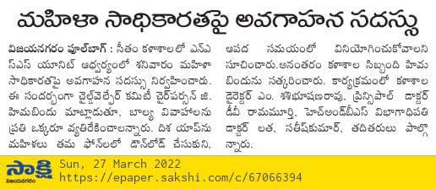

Common Rooms
SITAM recognizes the special and focused need of girl students during the college hours .The privacy needed and the amenities required are provided via girls’ common room. Easily accessible girls’ common room is provided with attached washroom and beds. Common rooms are available in the campus separately for boys and girls. The girls’ room is well equipped with emergency needs like sanitary napkin vending machines and first aid kits. The hostel is also equipped with a sick room and a clinic.

