SITAM

Satya Institute of Technology And Management
NAAC ACCREDITED
Approved by AICTE, New Delhi and Govt. of A.P. Affiliated to JNTUK, KAKINADA
Gajularega, Kondakarakam (P.O), Vizianagaram – 535003 Contact : 9676788811/9885758562, 08922-234775/9
e-mail: sitam@sitam.co.in, principal@sitam.co.in, Facebook : sitam.sgvp, website : www.sitam.co.in
JNTUK Code : B6 EAMCET Code : SGVP

Qualitative Metrics
Criterion VI-Governance, Leadership, and Management

6.2.1 Perspective /Strategic plan and Deployment documents are available in the institution.

Strategic planning is a continuous process with a specific focus on accomplishing institutional goals in this competitive world. Strategic Planning and deployment document (SPDD) is based on analysis of current obstacles and future opportunities and envisages the direction towards which the organization should move to achieve its set goals and objectives. Picture below shows the SP formulated at SITAM for it to walk into the "highway" of learning places and achieve its stated goals.

.

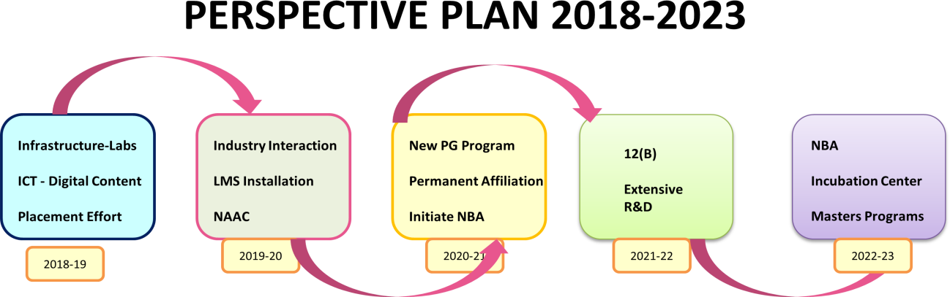

The table below briefly describes the events stated in the Perspective plan shown above.

S.No. | Academic Year | Event Planned | Outcome Realized
1 | 2019-20 | Industry Interaction | Many industries visited SITAM and established mutually beneficial MoUs.  Internship potentialities for students are identified.
2 |  | Learning Management System | The LMS, uLektz is implemented in SITAM. Several quizzes and lot of digital content developed is placed on the "SITAM GVP-LMS"Application developed specifically for SITAM.
3 |  | NAAC | With severe competition, gearing up for systematization and getting external recognition becomes inevitable. SITAM is NAAC accredited and it will be renewed as per the regulations of NAAC.
4 | 2020-21 | New PG programs | Post graduate programs serve as strengthening points of an education institution since research is facilitated by the presence of graduate students working towards their major project. As of now two PG were sanctioned and further new programs are being planned.
5 |  | Permanent Affiliation | Permanent affiliation obviates repetitive documentary and physical inspections and thus lot of time is freed for planning developmental activities. Besides Permanent Affiliation is a needed prerequisite for some of the governmental schemes.
8 | 2021-22  2022-23 | 12(B) | The University Grants Commission (UGC) provides financial assistance to eligible colleges which are included under Section 2(f) and declared fit to receive central assistance (UGC grant) under Section 12 (B) of UGC Act, 1956 as per approved pattern of assistance under various schemes. This makes our institution eligible for central assistance from the Government of India or any organization receiving funds from the Central Government.
 |  | Research Center | The Center for Research in Mathematics, aims to provide support and foster collaboration among researchers interested in conducting externally-funded interdisciplinary research on the teaching and learning of mathematics, the conditions that influence it, and innovations that maximize it.
 |  | NBA | Strengthening individual programs with  NBA accreditation validates quality standards which in turn improves student performance and fosters trust in the institution.
 |  | Autonomous | Autonomy gives greater flexibility towards purely academic development for improving academic standards and excellence. Promotes healthy practices such as community service, extension activities, projects for the benefit of the society at large and also promotes use modern tools of educational technology to achieve higher standards and greater creativity

Mathematics Research Center is sanctioned to Satya Institute of Technology And Management by JNTUK.

- 1. The following picture represents the Sanctioned letter by JNTUK.
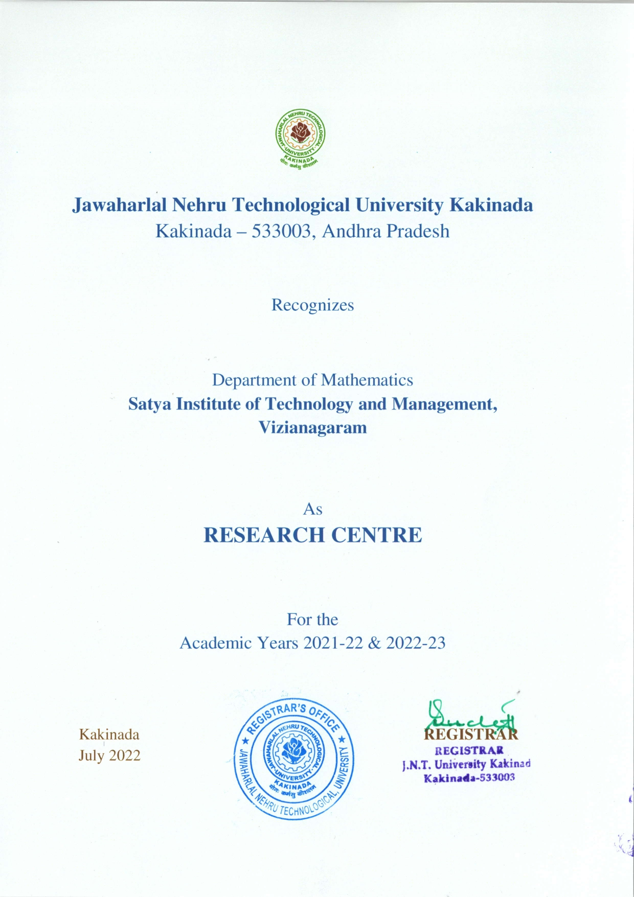
Satya Institute of Technology And Management is granted 12(B) by University Grants Commisssion.

- 1. The following picture represents the order issued to Satya Institute of Technology and Management, regarding 12(B).
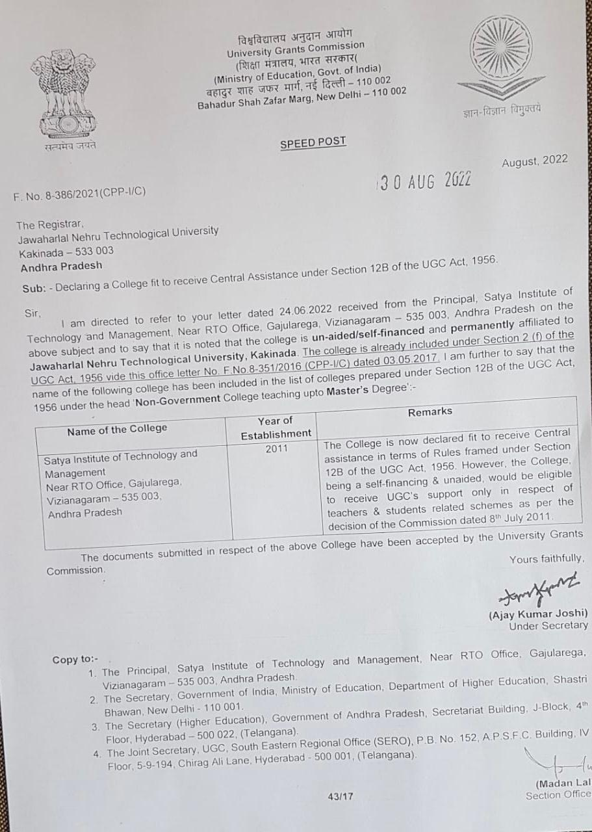

- 1. The following picture represents the order issued to Satya Institute of Technology and Management, by AICTE regarding Sanction of PG Program.

