SITAM
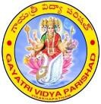
Satya Institute of Technology And Management
NAAC ACCREDITED
Approved by AICTE, New Delhi and Govt. of A.P. Affiliated to JNTUK, KAKINADA
Gajularega, Kondakarakam (P.O), Vizianagaram – 535003 Contact : 9676788811/9885758562, 08922-234775/9
e-mail: sitam@sitam.co.in, principal@sitam.co.in, Facebook : sitam.sgvp, website : www.sitam.co.in
JNTUK Code : B6 EAMCET Code : SGVP

Qualitative Metrics
Criterion VI-Governance, Leadership, and Management

6.2.2 Functions of various bodies, service rules, procedures, recruitment, promotional policies as well as grievance redressal mechanism

SITAM follows a transparent and tightly knit organizational setup to ensure accountability, responsibility and clarity. Various cells, departments, and other bodies are accurately represented in the organogram. The organogram is widely publicised in the institute at various places so that everyone is aware of the responsibilities. The organogram is shown below.

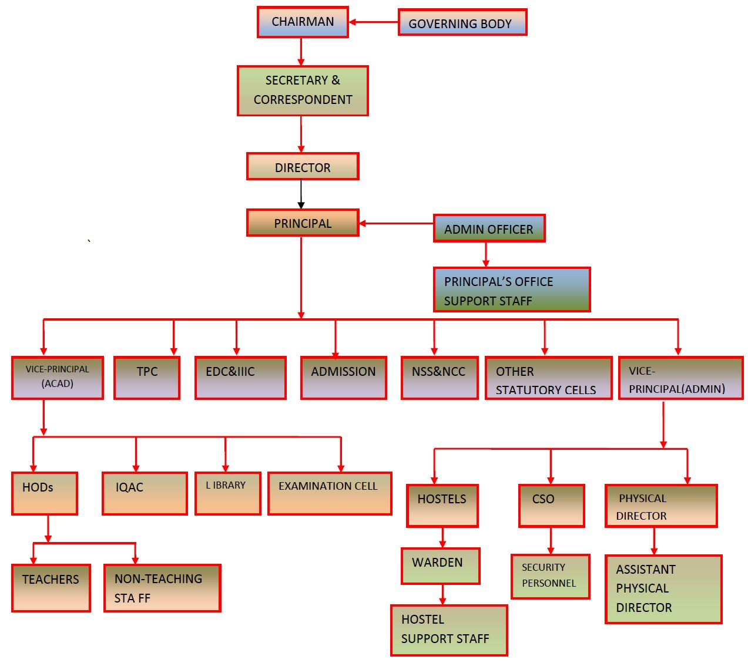
The functions key academic bodies and/or persons are indicated in the table below.

Position/Body | Functions
Governing Body | - Guides the institution in academics, student and faculty development, and R&D.  - Helps the institution in its pursuit to become a centre of excellence and establish milestones in continuous improvement.
Director | - Approves the budget presented by the Principal and monitors the budget utilization.  - Mobilizes resources for the development of the institution.  - Approves academic plans proposed by the Principal and allocates funds for its execution.  - Oversees the overall development of the institute.  - Day to day administration of college  - Manpower planning & Recruitment of the staff for college  - Development of college  - Expansion of the institute  - Students’ welfare  - Training & Development of staff  - Active member for strategic planning & decisions related to college.
Principal | - Defines and delegates various responsibilities in the organization.  - Ensures periodic monitoring & evaluation of various processes in the institute  - Ensures effective purchase procedure.  - Prepares annual budget in consultation with HODs.  - Conducts periodic meeting of various bodies such as Library Committee, Anti ragging committee and Women’s Grievances Redressal Committee etc.  - Prepares and executes academic calendar.  - Monitors and evaluates teaching learning process periodically and suggests corrective measures.  - Constitutes student council.  - Arranges internal audits.  - Maintains minutes of all meetings.  - Initiates new academic proposals.  - Arranges Faculty/Staff Development Programs.  - Conducts Students’ feedback analysis  - Conducts weekly meetings with H.O.Ds and periodic meetings with Faculty/Staff members to review the academic progress
Internal Audit committee(IAC) | - Oversees the Teaching Learning Process  - Carries out result analysis and suggest corrective measures.  - Initiates supplementary teaching measures.  - Arranges Orientation programs for first year students  - Arranges periodic Academic audits
Heads of Departments | - Allocates workload for faculty members.  - Guides faculty members to organize lectures and laboratory sessions and monitors the same.  - Ensures alternative arrangement when faculty goes on leave.  - Reviews students’ performance.  - Adopts measures for modernizing and developing labs  - Initiates measures for motivating faculty and developing team spirit  - Chairs Academic Committee  - Deputes staff in the proper conduct of examinations and evaluations.  - Organizes interactive meetings with students, and arranges feedback sessions.  - Oversees the creation and maintains a departmental database of faculty, alumni and students.  - Motivates staff members to organize consultancy and continuing education programs.  - Identifies new courses and programs  - Oversees planning of departmental activities: Timetable, Schedule of laboratories etc.  - Identifies training needs of faculty and supporting staff.  - Reviews the progress of sponsored projects, if any.  - Recommends and forwards Leaves and submissions to administration.  - Carries out performance assessment of faculty to improve faculty performance.  - Conducts meetings of supporting staff of the department, at appropriate intervals.  - Conducts monthly meeting of faculty to review the department work and records minutes of meeting(MOM )
Administrative Officer | - Co­ordinates the administrative and accounting activities  - Maintains up-to-date master documents with history of revision.  - Oversees Employee Attendance System & maintains the monthly attendance report.  - Manages public relations  - Maintains personal files of Faculty/Staff
Research and Development Cell | - Plans and executes activities for the promotion of research activities.  - Maintains list of publications of the faculty / students in chronological order.  - Maintains Hard–Copies of research papers / technical reports published in National / International Conferences / Journals (again chronologically).  - Maintains copies of text books authored by the faculty to be maintained  - Maintains list of Journals (Hard copies / online) available in the library.  - Maintains details of various conferences attended/ organized by faculty members.  - Collects and maintains records of literature on various latest research areas.  - Collects and maintains records of projects, mini­ projects, new ideas, research work etc. taken up by students.  - Collects and maintains records of research work being carried out by our faculty.
Placement and Training Cell | - Arranges student Training and Placement programmes  - Maintains list of companies offering jobs / career opportunities for the students  - Organizes special programs for career guidance.  - Maintains database of placed students  - Conducts special training and counseling programmes for weak students
Library  Committee | - Plans and implements routine activities of the library  - Plans and proposes upgradation/ development  - Maintains records regarding the titles / volumes of books available.  - Maintains Digital Library, online subscriptions etc.  - Generates requirement / purchase orders for new titles / volumes in accordance with the requirements.  - Maintains budgetary requirements and expenditure statements /records.  - Maintains library discipline and promotes library usage
Industry Institute Interaction Cell | - Establishes a strong relationship between the institute and industry, creating a mutually beneficial partnership.  - Promotes closer interaction between the academic field and the professional field.  - Organizes Workshops, conferences and symposia with participation of the faculty and the industries.  - Arranges visits of staff members to various industry  - Arranges internship programs for students
Innovation and Entrepreneurship Development Cell | - Organizes entrepreneurship awareness camps, orientation workshops, entrepreneurship development programs, Faculty development programs and skill development programs in the institution.  - Initiates innovative student projects for new innovative product development.  - Guides and assists prospective entrepreneurs on various aspects such as preparing project reports, obtaining project approvals , loans and facilities from agencies of support system  - Arranges interaction with entrepreneurs and mentorship scheme for student entrepreneurs.
Internal Quality Assurance Cell (IQAC) | - Adopts measures to develop a quality system for conscious, consistent and catalytic programmed action to improve the academic and administrative performance of the College  - Promotes measures for institutional functioning towards quality enhancement through internationalization of quality culture and institutionalization of best practices

With the responsibilities clearly laid out, SITAM teachers administer teaching assignments without any distractions: that was the idea of SITAM group to begin with.

Governing body:

Sl.No | NAME OF THE GOVERNING BODY | ADDRESS | DESIGNATIO N
1 | Sri Botcha Satyanarayana | Chief Patron,Satya Institute of Technology And Managament,Vizianagaram | Hon'ble Chairman
2 | Smt. Dr. B.Jhansi Laxmi | Secretary, Satya Institute of Technology And Managament,Vizianagaram | Secretary and Correspondent
3 | Prof. P. Somaraju | Secretary,Gayatri Vidya Parishad, Visakhaptnam. | Hon'ble Secretary
4 | Smt.Dr.S.Anusha | Treasurer,Satya Institute of Technology And ManagamentVizianagaram | Revered Treasurer
5 | Prof.M.SashiBhushanarao | Joint Secretary,Satya Institute of Technology And Managament | Revered Joint Secretary
6 | Smt.Dr.G.JayaSuma | Professor and Head Of the Dept.of InformationTechnology,JNTUK UCE,Vizianagram | Hon'ble JNTUK Nominee
7 | Sri.Ch.Srinivasa Rao | Principal ,JNTUK,Narasaraopeta | Distinguished Member
8 | Sri.G.Swami Naidu | Principal,JNTUCEV ,Vizianagaram | Distinguished Member
9 | Smt.Dr.M.V.Saidevamani | Principal of Satya Degree & PG College,Vizianagaram | Special Invitee
10 | Sri.M.S.S Sarma | CHIEF EXECUTIVE OFFICER,Ferro  Alloys Corporation(FACOR), Vizianagaram | Distinguished Member
11 | CH.Venkata Lakshmi | Vice- Principal,Satya Institute of Technology And Managament,Vizianagaram | Faculty Representative
12 | Sri T.D.V.A. Naidu | Assoc. Prof.Satya Institute of Technology And Management, Vizianagaram | Faculty Representative
13 | Mr. S.Bhanu Pavan | Associate Software Engineer, Tata Consultancy services, Kochi, Alumni., | Member
14 | Prof. B. V. Sarma | Professor, Civil Engineering,SATYA INSTITUTE OF ENGINEERING AND TECHNOLOGY, VIZIANAGARAM | Distinguished Faculty Member
15 | Dr. D.V. Ramamurthy | Principal,Satya Institute of Technology&Managament,Vizianagaram | Member Secretary

Service and Promotion rules:-

The institute has a HR manual in practice to delineate all aspects of service.The service rules decided by the UGC and the State Government for the appointments and Promotions of the Teachers, Director of Physical Education and Librarian, are aptly represented in the HR manual.

Recruitment and selection:

  - Recruitment and selection is always by AICTE/JNTUK rules.

  - Recruitment and selection sometimes are by need based prescribed by work based from each department.

  - Staff selection committee will be considered.

  - For teaching post, the Candidate should present a demo lecture and then an interview by selection committee followed by Principal in face-face interview.

  - For a non-teaching post, the selection is by practical test conducted by HOD in respective department Labs and finally by principal in one-one interview.

  - Eligibility Criteria, Qualification and salary as per norms of AICTE

Grievance Redressal Mechanism:

There are separate Grievance Redressal Committees for students and staff. If teachers and students are not satisfied, they can appeal to the Governing Body or ultimately to the Grievance Redressal Committee of the Institution. The College has set up a complaint box for faculties, staff and students. The grievance redressal committee discusses the complaints and takes decision accordingly. The mechanism for dealing with complaints is as follows,
The Principal receives complaints orally or in writing. Received Complaints are discussed in the committee meeting and resolved to take action on the concerned issues. A separate Anti-Sexual Harassment Committee is formed to prevent persecution and investigate girls' student complaints. An Anti-Ragging Committee has also been set up to resolve the cases of demolition.

GRIEVANCE FORMS:
Link for student grievances is http://bit.ly/SITAM-Grievances
Link for Grievance form for staff is https://bit.ly/SITAM-STAFF-Grievance

